**MAKERERE  UNIVERSITY**

**COLLEGE OF COMPUTING AND INFORMATION SCIENCES**

**(YEAR II) RECESS TERM**

**SOFTWARE REQUIREMENT SPECIFICATION DOCUMENT (SRS)**

**FOR PYTHON PROJECT**

**PROJECT MEMBERS**

|  |  |  |
| --- | --- | --- |
| **NAME** | **REGISTRATION NUMBER** | **STUDENT No** |
| Nagaba Angel | 17/U/726 | 217000189 |
| Okello Marvin Kevin Ochira | 17/U/9569/PS | 217017015 |
| Karungi Lydia | 17/U/4676/PS | 217002012 |
| Wepukhulu Bruno | 17/U/10891/PS | 217012574 |

**PROJECT COORDINATOR**: MR. KAMULEGEYA GRACE

## INTRODUCTION

**PURPOSE**

A system requirements specifications(SRS) document describes what the system will do and how it will be expected to do it . This document will include a use case diagram which shows how the system interacts with the outside world.

**Document conventions**

This document is edited using the following formats, font size 12, font style times new roman, line spacing 1.5. it was generated based on the guidelines provided by our recess coordinator Mr.Grace Kamulegeya.

**Intended audience and Reading suggestions**

The intended audience for this project includes, the data scientists(students working on the project), developers, Data clerks in police, policy makers, road users(drivers, riders, pedestrians, passengers), Researchers, document writers(can use it as a reference).

**Project scope**

The purpose of this project is to aim at reducing the death rate caused by accidents. The project is based on the data that is collected by the police in the UK transport department every time an accident happens with the help of the report form this data can be found at [http://docs.adrn.ac.uk/888043/mrdoc/pdf/888043\_stats19-road-accident-injury-statistics-report-form.pdf](http://docs.adrn.ac.uk/888043/mrdoc/pdf/888043_stats19-road-accident-injury-statistics-report-form.pdf" \l "inbox/_blank" \t "https://mail.google.com/mail/u/1/)

We shall analyse and visualise the data to come up with insights that will help us to recommend policies to help reduce the deaths caused by accidents. The insights will also help us to advise road users based on the occurrence causes of accidents.

**The users of the Data Science Pipeline include the following:**

* Data scientists

These are the developers of the system. They extract the relevant data from the data collected by the police and clean it, visualize it, model the data and interpret it.

* Data clerks in the Police.

These enter the collected data into the system. From they get the data from the Report forms in which information is recorded when an accident occurs.

* System Administrators

These have access rights to the system and carry out analysis of the data.

* System testers

These test the functionalities of the system, how correct the data output is and whether all needs of the users are fully satisfied.

**USE CASE DIAGRAMS**

Ause case diagram helps to describe the system’s behaviour and how a system interacts with outside world. The use case diagram consists of actors (who interacts with the system) and use cases(this shows what the actors do with the system). A use case basically helps in understanding of the system form the end user’s point of view.

GENERAL USE CASE DIAGRAM

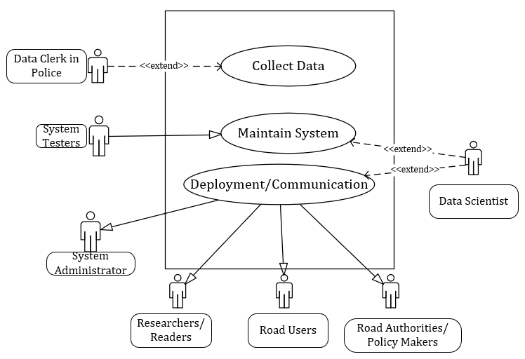

Source: Generated by the group using Microsoft Visio

EXPANDED USE CASE DIAGRAM

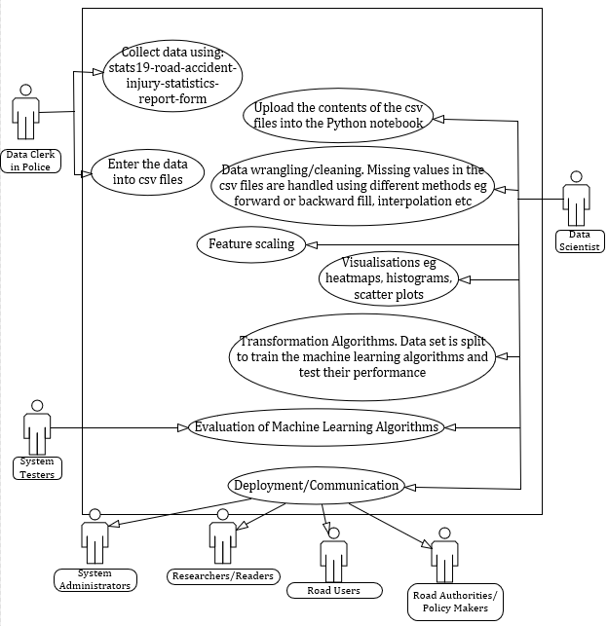

Source: Generated by the group using Microsoft Visio

**Roles of the Actors in the Use case Diagram**

|  |  |
| --- | --- |
| **Actors** | **Role** |
| **System Analyst** | Upload the data from csv into python Notebook  Clean the data  Feature scale  Visualize the data  Apply Machine Learning Algorithms  Evaluate the Algorithms  Deploy/Communicate |
| **Road Users** | View Predictions in outcomes when accidents occur.  View the Visualizations of accident data |
| **Road Authorities/Policy Makers** | View Predictions in outcomes when accidents occur.  View the Visualizations of accident data  Make policies resulting from the Findings from the Analysis |
| **Researchers/Readers** | View Predictions in case of accident occurrence  View the Visualizations of accident data |
| **Data Clerks** | They enter data from the forms into csv file format |
| **System Testers** | They evaluate the machine learning algorithms |